1. **Agenda**:
   1. How to call REST API via Camel?
2. **camel-microservice-b** will contain REST API whereas **camel-microservice-a** will contain router calling REST API from **camel-microservice-b.**
3. First, create REST API.  
   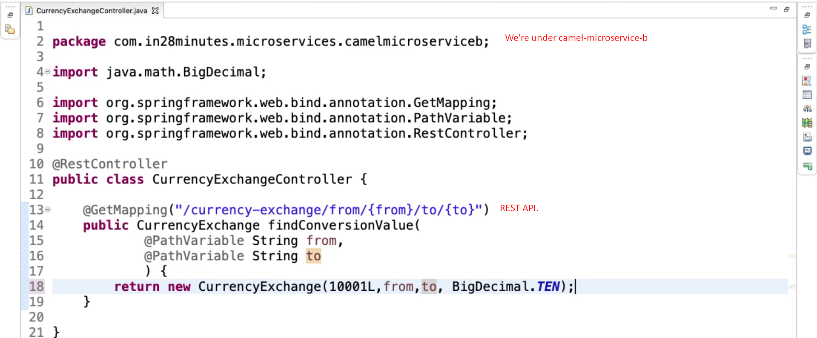
4. Let’s create a consumer router in **camel-microservice-a**.  
   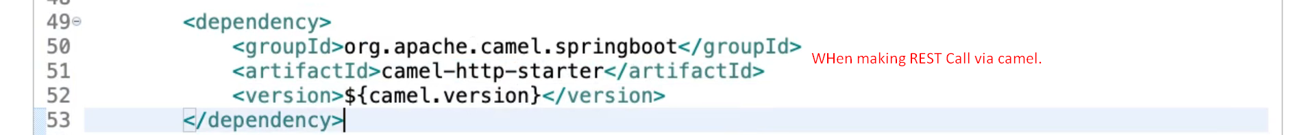  
   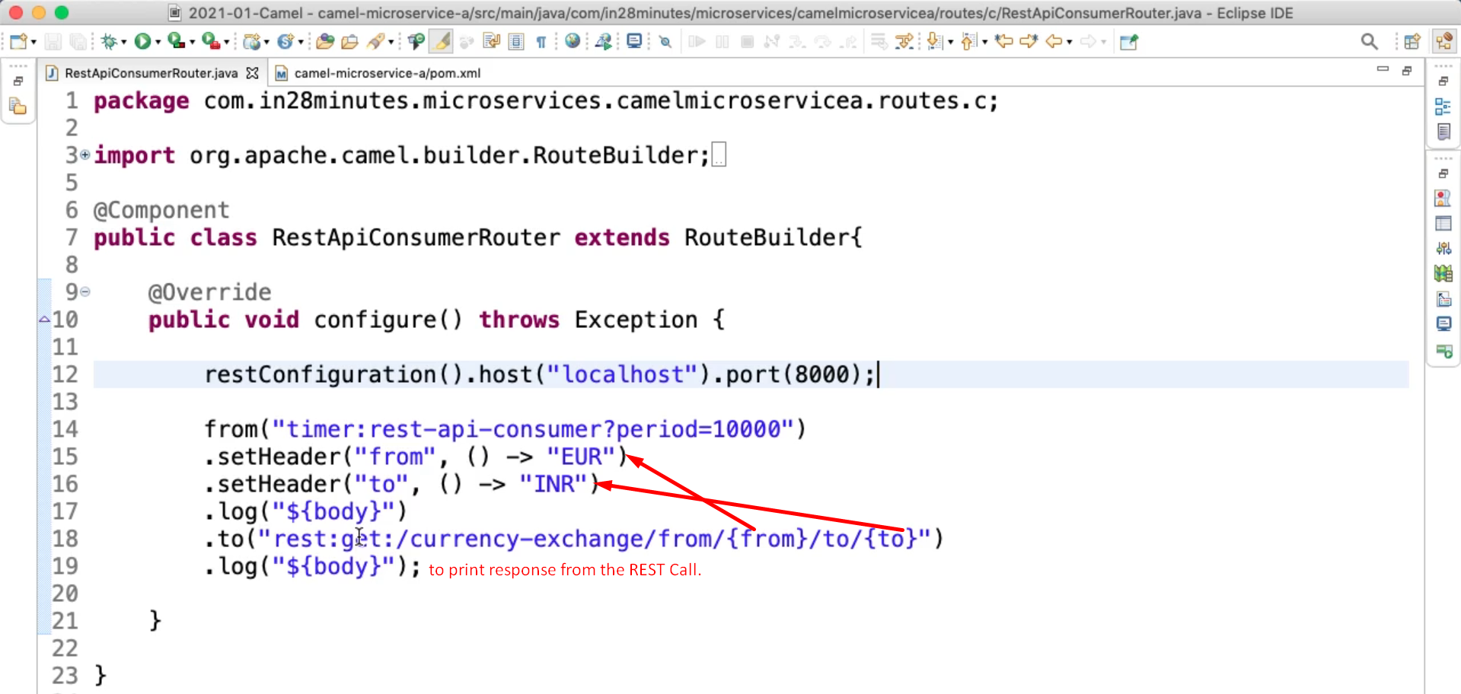  
   **NOTE**: Line#14 will call the REST API after every 10sec.